**CREATING A FIREWALL IN LINUX USING IPTABLES**



Flush old rules

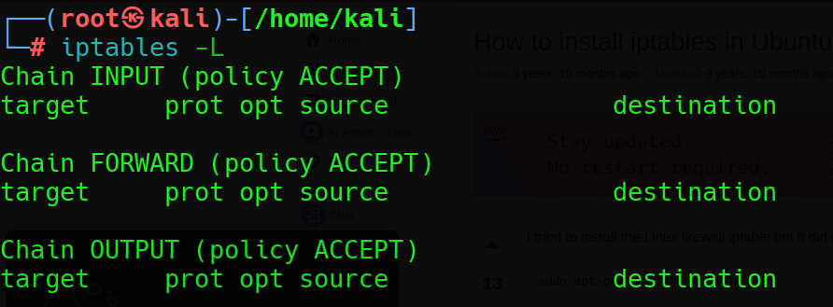

List of all initial firewall rules in my system

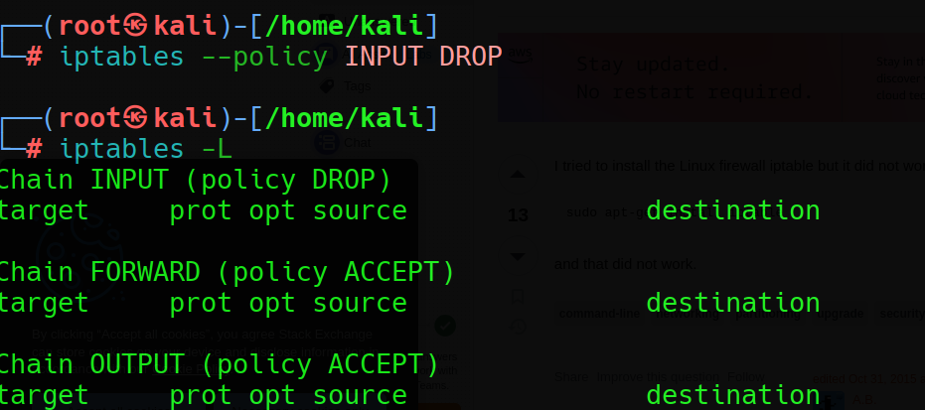

Made INPUT chain to drop all incoming packets

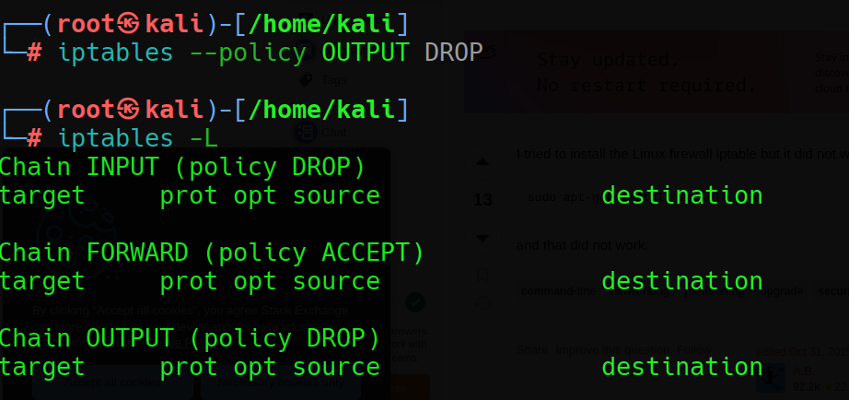

Made OUTPUT chain to drop all the outgoing packets

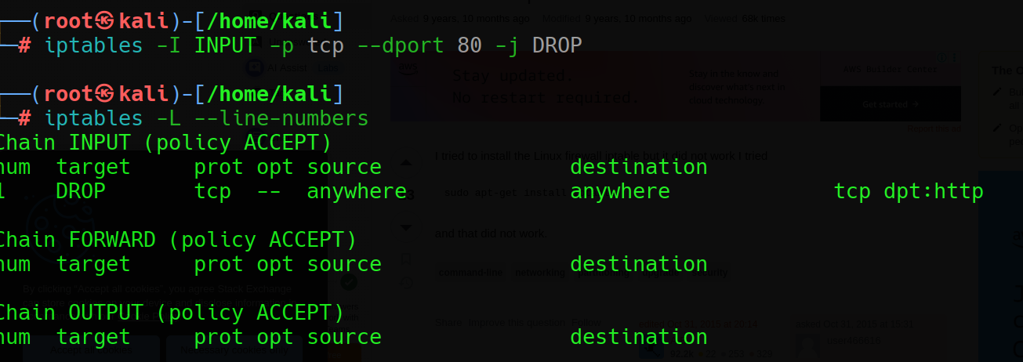

Block SSH packets

Delete the 1st firewall rule

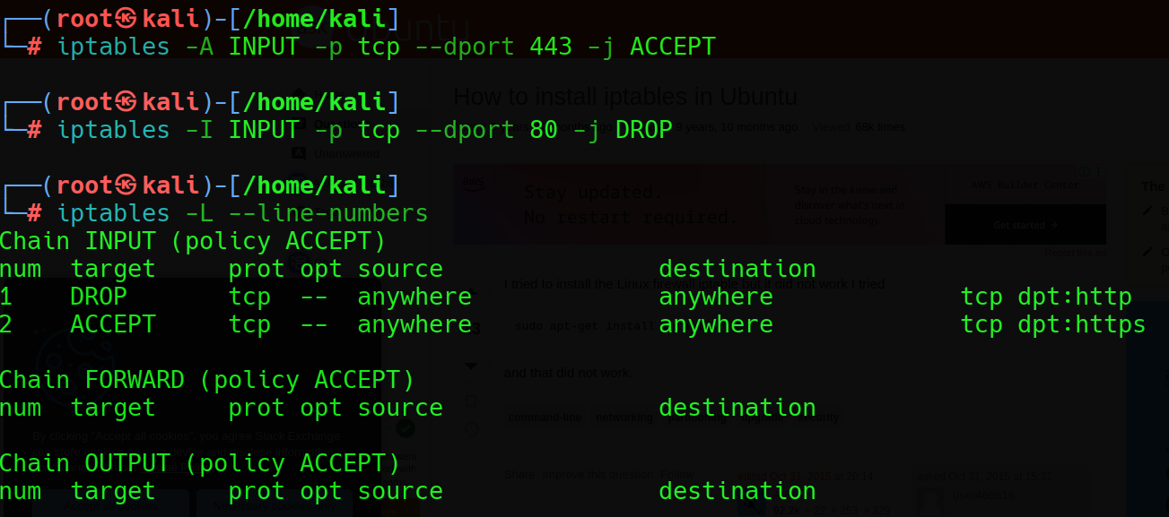

Allow HTTPS packets and block SSH packets